**Applying Table of rules on graph**

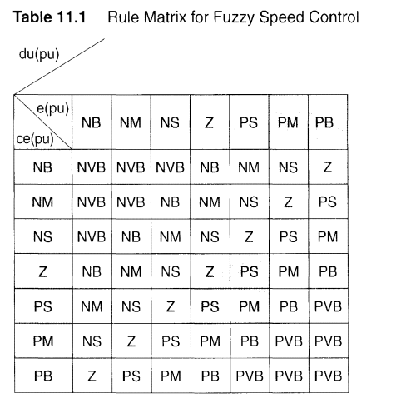

**e:NB and ce NB then cU : NVB**



**e:NM and ce NB then cU : NVB**



**e:NS and ce NB then cU : NVB**

